Tanya Agathocleous
Spring 2021
ENG 32259/WGS 3001G-01
M/Th 1:10pm – 2:25pm
Online

Decolonizing Gender between Text and Image
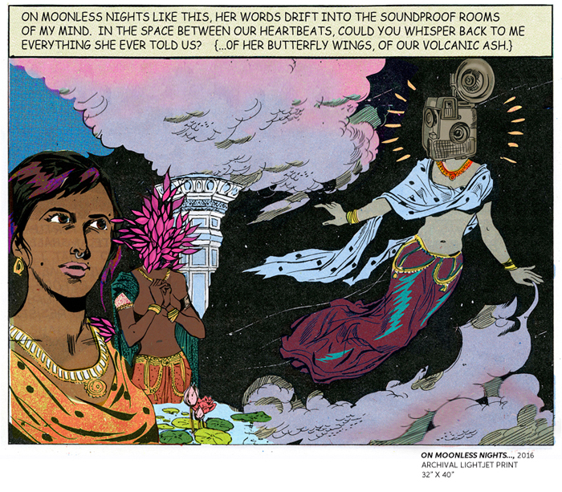

The politics of colonial resistance and egalitarian feminism arose alongside each other and share an overlapping history and vocabulary. The notion of liberation is central to both and in its service the two movements have intersected, interrupted, aided and undermined each other. As feminist postcolonial theorists such as Lila Abu-Lughod and Gayatri Spivak have argued, colonialism has instrumentalized feminism and vice versa. This course analyzes the historical intersection of feminism and anti-colonialism through the relationship between image and text, with close attention to phenomena such as harem photography, political cartoons, photo albums, and instances of Third Cinema. The class is aimed at students who seek to deepen their theoretical knowledge of postcolonial and feminist theory and develop new frameworks for analyzing the relationship between image and text. Alongside feminist and postcolonial theoretical texts, we will read biographical works such as Imperial Intimacies, poems, short stories (such as “Sultana’s Dream”) and novels such as Jane Eyre, Wide Sargasso Sea, Lucy, Persepolis, and The Power; discuss films such as The Battle of Algiers; and consider works of painting and photography.

Contact Information:
Tanya Agathocleous
tagathoc@hunter.cuny.edu

Zoom office hours:
Mon-Fri, by appointment

Required Texts:
The following texts (except The Power) are available through Akademos. All other texts will be provided via Blackboard. For the sake of your poor, over-strained eyes, hard copies of the novels are strongly recommended.
Recommended edition
- Brontë, Charlotte. Jane Eyre. 1847. Penguin Classics
- Rhys, Jean. Wide Sargasso Sea. 1966. Norton
- Kincaid, Jamaica. Lucy. 1990. FSG
- Satrapi, Marjane. Persepolis. 2000. Random House
- Alderman, Naomi. The Power. 2016. Little, Brown and Co.

Grade Distribution:
- Participation (20%)
- Short paper (3 pages, single-spaced) (25%)
- Hypothes.is annotations (20%)
- Final writing assignment or project (35%)
- Regular attendance is mandatory—missing five classes or more will affect your final grade; missing seven classes or more may result in course failure. If you have to miss class for a good reason, please let me know before class if at all possible.
- You must have a working Hunter email or you will miss important instructions from me—if you are having email or other tech problems, please let me know asap.

Hypothes.is annotations:
Your annotation assignment is to do either one long or two short annotations at least once a week (comment on the specific portion of the text you have highlighted). A long annotation would be a few sentences long; a short annotation would be one-two sentences long. To get full credit by the end of the semester, you should have done at least one post per week starting week 2 of the semester for a total of at least 14 posts. Late posts do not count, as the purpose of the posts is to generate discussion for that week and to encourage you to engage with the reading. I will count two short annotations as one post.

Course Objectives:
- This is a reading- and writing-intensive course. Students will read, view, and analyze a range of primary texts related gender, empire, and anti-imperialism, as well as contemporary critical studies of these topics from a range of disciplines, including history, anthropology, literature and postcolonial studies.
- In reading primary sources, they will hone their critical thinking skills and their ability to analyze texts in the context of history, as well as in relation to the specificities and intricacies of language, visual culture, and media.
- Students will work on writing over the course of the whole semester and in a variety of forms, from the short close reading assignment to the longer final paper, paying special attention to the question of how to construct a compelling and original thesis and how to use textual support to support this thesis.
Schedule of Readings
(Come to class having read the material listed for that date).
2/1 | Introductions and Class Overview
2/4 | Orientalism, Text and Image  Edward Said, extracts from Orientalism  Deborah Cherry, “The ‘Worlding’ of Algeria: Feminism, Imperialism, and Visual Culture” from Beyond the Frame: Feminism and Visual Culture, Britain 1850-1900 (pp. 75-100).
2/8 | The British Novel and the British Empire  Charlotte Brontë, Jane Eyre (vol. 1 chpts. 1-15, up to p. 177 in our edition)  and the Female Bildungsroman  Optional reading: Susan Fraiman, from Unbecoming Women: British Women Writers and the Novel of Development
2/11 | Jane Eyre (vol. 2, chpts 16-27, up to p. 370)  and Orientalism  Optional reading: Edward Said, Culture and Imperialism
2/15 | President’s Day – College Closed
2/18 | Jane Eyre (vol. 3, chpts 28-38, to end of novel)  Race and empire  Optional reading: Shu-mei Shih, “Comparative Racialization”
2/22 | Orientalism and Visual Culture 1  Frederic N. Bohrer Orientalism and Visual Culture, Intro and Ch. 1  Tate Britain exhibit  https://www.tate.org.uk/whats-on/tate-britain/exhibition/lure-east-british-orientalist-painting/explore-exhibition
2/25 | Orientalism and Visual Culture 2  Malek Alloula, The Colonial Harem [1986] [read excerpts]
3/1 | Gender, Anthropology, and Colonialism  Ann Stoler, from Carnal Knowledge and Imperial Power  Z. S. Strother “Display of the Body Hottentot” in Africans on Stage: Studies in Ethnological Show Business (ed. Bernth Lindfors) (pp. 1-61).  Optional reading: Saidiya Hartman, “Venus in Two Acts”
3/4 | Jean Rhys, Wide Sargasso Sea
3/8 | Wide Sargasso Sea
3/11 | Kara Walker, A Subtlety  https://creativetime.org/projects/karawalker/  Khalil Gibran Muhammad, “The Sugar that Saturates the American Diet Has a Barbaric History as the ‘White Gold’ that Fueled Slavery,” New York Times (1619 Project), Aug. 14, 2019:  https://www.nytimes.com/interactive/2019/08/14/magazine/sugar-slave-trade-slavery.html  Smart History: The Triangle Trade and the Colonial Table, Sugar, Tea, and Slavery:  https://www.youtube.com/watch?v=osAtCi-W1bk&list=PLugP0T-YRCWKA5awSUe8PBrBMcZYykqJH
3/14 | <<<Mid-term paper due>>>
3/15 | Mother India 1  Christina Rossetti, “In the Dark Tower at Jhansi” (1857) and Alfred Tennyson “The Defense of Lucknow” (1880)  Cartoons from Hindi Punch (1905) and Cartoons Against Corruption (2012)  https://cartoonsagainstcorruption.blogspot.com/  Tanika Sarkar Hindu Wife, Hindu Nation: Community, Religion, and Cultural Nationalism, pp. 192-267.
3/18 | Mother India 2  Katherine Mayo Mother India [1927] [read excerpts]  http://gutenberg.net.au/ebooks03/0300811h.html  Mrinalini Sinha, Specters of Mother India: The Global Reconstruction of an Empire, (pp. 1-65)
3/22 | The Wonderful Adventures of Mary Seacole in Many Lands
3/25 | Mary Seacole and visual culture  Hazel Carby, extract from Imperial Intimacies
3/27-4/4 | <<<<<<Spring Recess>>>>>>
4/5 | Anne McClintock, Imperial Leather  Chapters 3 and 5
4/8 | Jamaica Kincaid, Lucy
4/12 | Politics of the Veil 1  Persepolis
4/15 | Persepolis/film version
4/19 | Politics of the Veil 2  The Battle of Algiers  Matthew Evangelista, from Gender, Nationalism, and War (Chpt 2)
4/22 | Women of Algiers  Helene Cixous, “Letter to Zohra Drif”  Assia Djebar, “Hidden Gaze, Severed Sound”  Paintings: Delacroix, Picasso, Baya
4/26 | Politics of the Veil 3  Joan Scott, “The Vexed Relationship of Emancipation and Equality”  Chapter 1 from The Politics of the Veil
4/29 | Utopias/Dystopias  Sultana’s Dream  https://digital.library.upenn.edu/women/sultana/dream/dream.html  Chitra Ganesh, “Her Garden, A Mirror”  https://thekitchen.org/event/chitra-ganesh-her-garden-a-mirror
5/3 | The Power
5/6 | The Power
5/10 | The Power
5/13 | A Girl Walks Home Alone at Night
5/17 | Final Paper Workshop

Course Policies and College Regulations

Zoom and Classroom Etiquette:
- This is a discussion seminar. While it’s not a requirement of the course for reasons of equity, it is the expectation of the class that you will have your camera on: please email me in advance if this ever poses a problem for you. This class deals with difficult subjects, including sexual and colonial violence, and we’re living through extremely difficult times—it is imperative that we are respectful and supportive of each other and create an environment that offers us a place to think, process, create and critique the past and use it to understand the present. Showing up, participating, and having your camera on will help build community and trust so that we can learn from each other and, hopefully, enrich each other’s lives during the time we are together. For this reason, please do your best not to be distracted by other things on the internet or your phones, or leave class in the middle. To summarize: be present, be present, be present.

- Using the chat function: some people are shyer than others and prefer to write their comments and questions in the chat, or occasionally have to have their sound off because of background noise so it’s the best way for them to contribute. However, the chat can also be distracting and we don’t want our attention to be divided, so please use it sparingly and avoid having separate conversations there (though you’re welcome to use it to actually chat while we’re waiting for everyone to log on at the beginning of class).

- Using the ‘raise hand’ function: this is the best way for me to see if you want to speak, as I won’t always be able to see everyone on the screen at once.

Participation policy:
Classroom participation constitutes a significant proportion of your grade. If you do not participate your final grade may be as much as one whole grade lower than it would have been if you did participate.

A – regular and thoughtful, well-supported participation
B – moderate participation
C – hardly any participation
F – no participation

Please come to class having done the reading and prepared questions and thoughts about it; mark up your text and jot down notes as you read so that your input is as specific and focused as possible. Buy hard copies of the books if at all possible.

Writing assignments policy:
Instructions for submission will be provided on writing assignments. All writing requirements must be completed in order to pass the class. Papers more than one week late without permission will not be accepted—if you are having trouble with your paper and getting it done for any reason, please let me know so I can help you and/or grant you an extension.

Academic Honesty:
The university policy will be strictly upheld in this class. Hunter College regards acts of academic dishonesty (e.g., plagiarism, cheating on examinations, obtaining unfair advantage, and falsification of records and official documents) as serious offenses against the values of intellectual honesty. The college is committed to enforcing the CUNY Policy on Academic Integrity and will pursue cases of academic dishonesty according to the Hunter College Academic Integrity Procedures. Any misconduct will result in university disciplinary action.

Academic Accommodation:
In compliance with the American Disability Act of 1990 (ADA) and with Section 504 of the Rehabilitation Act of 1973, Hunter College is committed to ensuring educational parity and accommodations for all students with documented disabilities and/or medical conditions. It is recommended that all students with documented disabilities (Emotional, Medical, Physical and/or Learning) consult the Office of AccessABILITY located in Room 1124 East to secure necessary academic accommodations. For further information and assistance please call (212-772-4857) / TTY (212-650-3230).

Hunter College Policy on Sexual Misconduct:
In compliance with the CUNY Policy on Sexual Misconduct, Hunter College reaffirms the prohibition of any sexual misconduct, which includes sexual violence, sexual harassment, and gender-based harassment retaliation against students, employees, or visitors, as well as certain intimate relationships. Students who have experienced any form of sexual violence on or off campus (including CUNY-sponsored trips and events) are entitled to the rights outlined in the Bill of Rights for Hunter College.
a. Sexual Violence: Students are strongly encouraged to immediately report the incident by calling 911, contacting NYPD Special Victims Division Hotline (646-610-7272) or their local police precinct, or contacting the College's Public Safety Office (212-772-4444).
b. All Other Forms of Sexual Misconduct: Students are also encouraged to contact the College's Title IX Campus Coordinator, Dean John Rose (jtrose@hunter.cuny.edu or 212-650-3262) or Colleen Barry (colleen.barry@hunter.cuny.edu or 212-772-4534) and seek complimentary services through the Counseling and Wellness Services Office, Hunter East 1123.
CUNY Policy on Sexual Misconduct Link: http://www.cuny.edu/about/administration/offices/la/Policy-on-Sexual-Misconduct-12-1-14- with-links.pdf

